1. par.inp:

Add:

integer NEVENTS, NBCKG1, NBCKG2, NCM

& ,NBCKGNORM1, NBCKGNORM2

COMMON/nsamples/NEVENTS, NBCKG1, NBCKG2, NCM

& ,NBCKGNORM1, NBCKGNORM2

After:

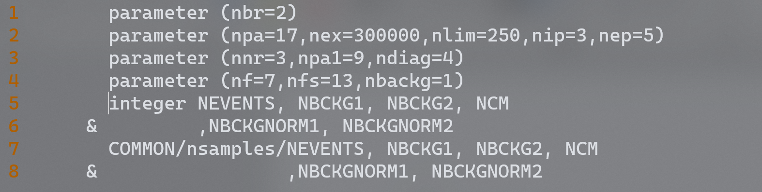

1. plot.f
   1. Annotation all: common/ndata/nevents,ncm……
   2. Annotation: nip=3
   3. Annotation: nep=5
   4. Annotation: common/coef/fun1(81,81,3),fun2(81,81,3)

then Add: common/coef/fun1(nf,nf,2),fun2(nf,nf,2)

* 1. Annotation: a=a+fun1(i,j,nt)*realpart(b)-fun2(i,j,nt)*imagpart(b)

then Add: a=a+fun1(i,j,1)*realpart(b)-fun2(i,j,1)*imagpart(b)

* 1. Line17:

Annotation: if(k.eq.0) then

Add: if(k.eq.0 .or. k.eq.20 .or. k.eq.30) then

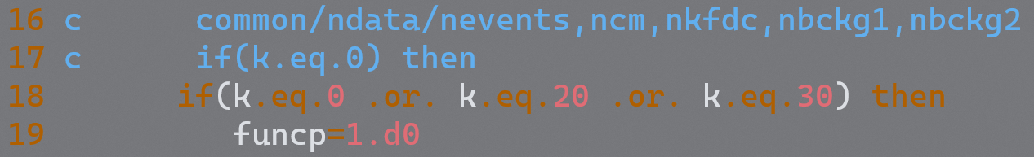

* 1. Annotation: funcp=(1.d0*nevents)/ncm

Add: funcp=(1.d0*(nevents-nbckg1-nbckg2))/ncm

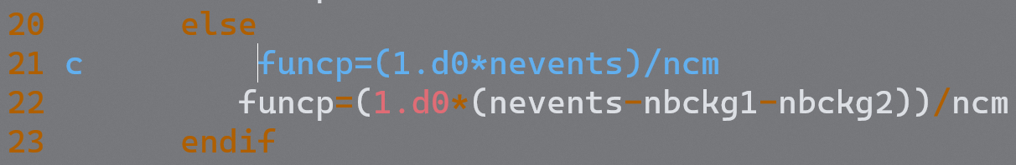

* 1. After: parameter (nwpawc=100000)

Add: include 'par.inp'



* 1. After: the lines ',i3,',...,',i3,' is data plot')

Annotation: else

Add: else if(m.eq.2) then

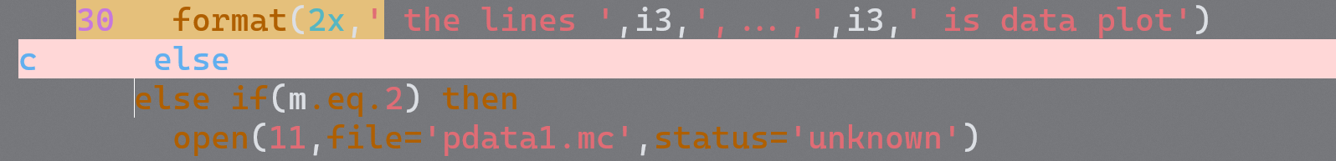

* 1. Annotation: FUNCTION cross_sec(n,k,m,nt)

Add: FUNCTION cross_sec(n,k,m)



* 1. After: 40 format(2x,' the lines '……

Add:

c*****************Edited by Ai X.C*****************

c else

c open(13,file='pbg1.dat',status='unknown')

c do 103 nevnt = 1,nbckg1

c do j=nip,nep

c read(13,*) (p(i,j),i=2,4),p(1,j)

c enddo

c a=a+funcp(k)

c 103 continue

c close(13)

c write(20,50) k+1,k+10

c 50 format(2x,' the lines ',i3,',...,',i3,' is bkg plot')

c*****************************************************

else if(m.eq.3) then

open(13,file='pbg1.dat',status='unknown')

do 103 nevnt = 1, nbckg1

do j=nip,nep

read(13,*) (p(i,j),i=2,4),p(1,j)

enddo

a=a+funcp(k)

103 continue

close(13)

write(20,50) k+1,k+10

50 format(2x,' the lines ',i3,',...,',i3,' is background 1 plot')

else

open(14,file='pbg2.dat',status='unknown')

do 104 nevnt = 1, nbckg2

do j=nip,nep

read(14,*) (p(i,j),i=2,4),p(1,j)

enddo

a=a+funcp(k)

104 continue

close(14)

write(20,60) k+1,k+10

60 format(2x,' the lines ',i3,',...,',i3,' is background 2 plot')

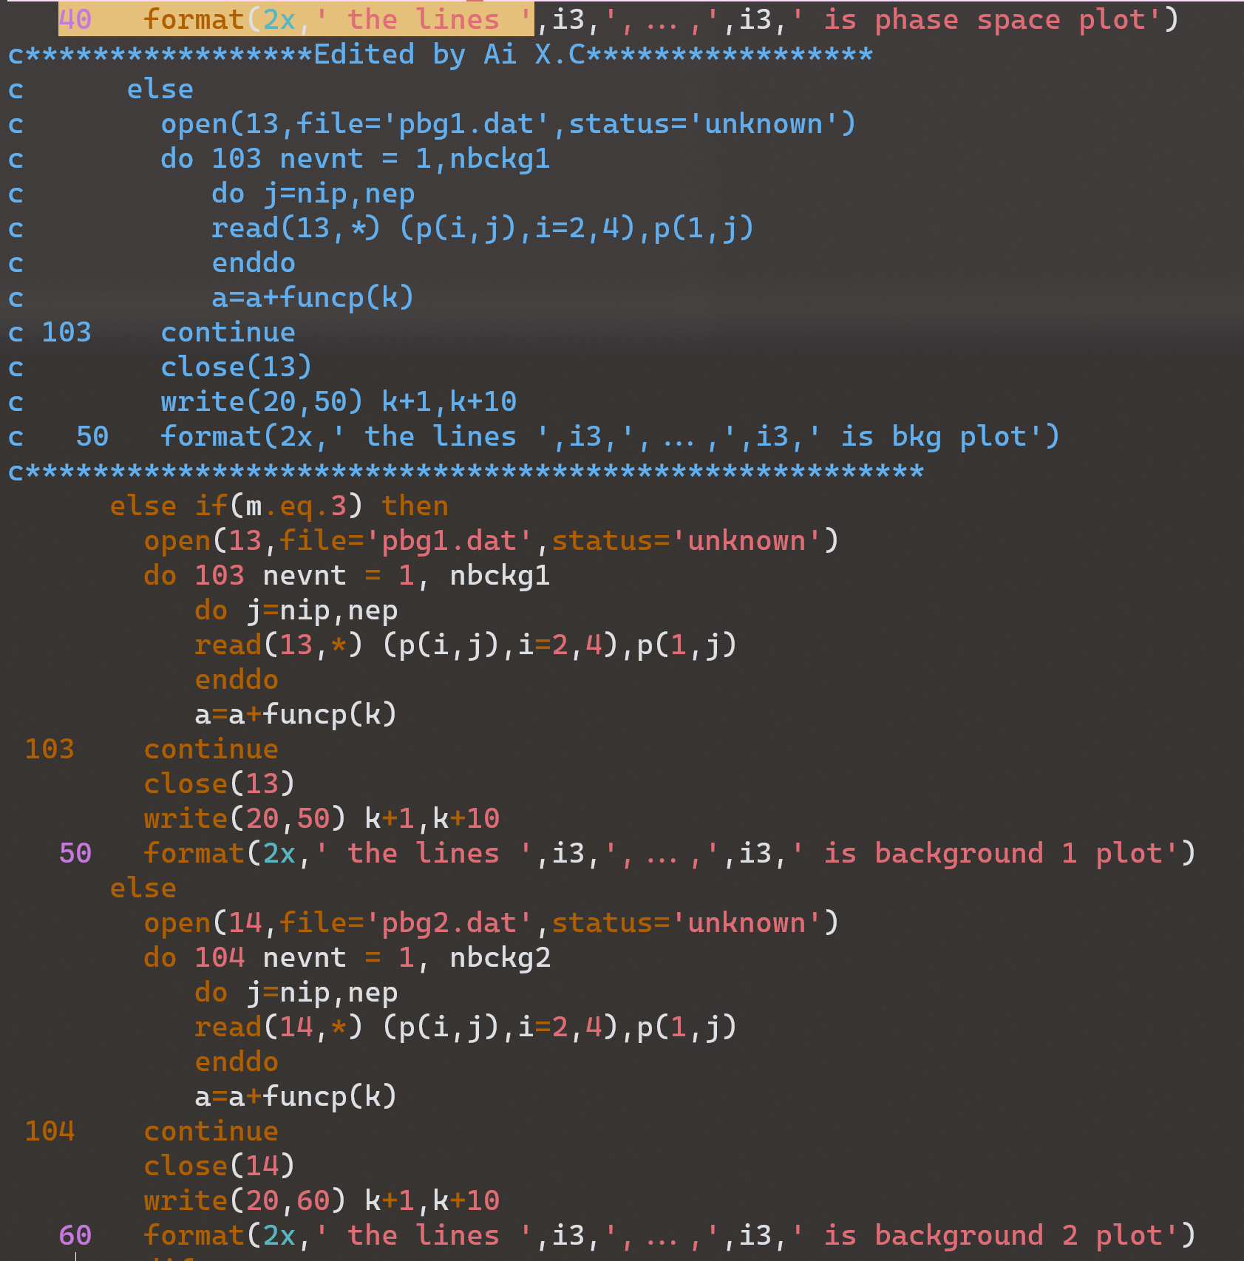

1. Copy files:
   1. read.f
   2. fum_spec.f
   3. spepfit.f
   4. cpepfit.f
2. Copy your own files: (The four momentum of the corresponding particle of the background)
   1. pbg1.dat
   2. pbg2.dat
3. Remake the program:

make

1. flag.inp

Add:

* 1. 'bkg1=' 766 833
  2. 'bkg2=' 699 723

quantity normalized quantity

